Implement program to apply moving average smoothing for data preparation and time series forecasting
EX:No.6
DATE:29/03/25

AIM:
Write a program to Implement program to apply moving average smoothing for data preparation and time series forecasting

ALGORITHM:
Step 1: Install required libraries (if not already installed).
Step 2: Import necessary libraries (pandas, numpy, matplotlib).
Step 3: Load air pollution data, parse dates, and set 'date' as the index.
Step 4: Remove duplicate timestamps and fill missing values.
Step 5: Select the 'pollution_today' column.
Step 6: Remove outliers using the IQR method.
Step 7: Ensure daily data frequency.
Step 8: Resample to weekly average (optional, not used in the plot).
Step 9: Create a figure and plot daily pollution levels as a line graph.
Step 10: Set labels, title, and legend for the plot.
Step 11: Show the plot.

CODE:

import pandas as pd
import matplotlib.pyplot as plt

# Load the time series data
file_path = r"/content/MSFT.csv"
df = pd.read_csv(file_path, parse_dates=["Date"], index_col="Date")

# Use the 'Close' column for analysis
ts = df["Close"].dropna()

# Apply Moving Average Smoothing
window_size = 12 # 12-month moving average (adjust as needed)
moving_avg = ts.rolling(window=window_size).mean()

# Forecasting using Moving Average
future_steps = 12 # Forecast for next 12 months (adjust as needed)
forecast_values = moving_avg[-1] # Last smoothed value as a baseline forecast
future_dates = pd.date_range(start=ts.index[-1], periods=future_steps + 1, freq="B")[1:] # 'B' for business days
forecast_series = pd.Series([forecast_values] * future_steps, index=future_dates)

# Plot Original, Smoothed & Forecasted Series
plt.figure(figsize=(12, 5))
plt.plot(ts, label="Original Time Series", alpha=0.5)
plt.plot(moving_avg, label=f"{window_size}-month Moving Average", color="red", linestyle="dashed")
plt.plot(forecast_series, label="Forecast (Moving Avg)", color="green", linestyle="dotted")
plt.xlabel("Date")
plt.ylabel("Closing Price") # Changed y-axis label
plt.title("Moving Average Smoothing & Forecasting (MSFT Closing Price)") # Updated title
plt.legend()
plt.grid(True)
plt.show()

OUTPUT:

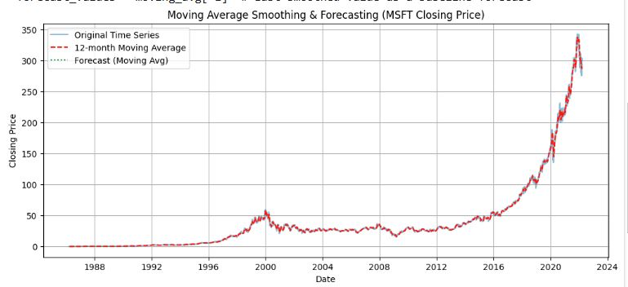
RESULT:
Thus, the program using the time series data implementation has been done successfully.

